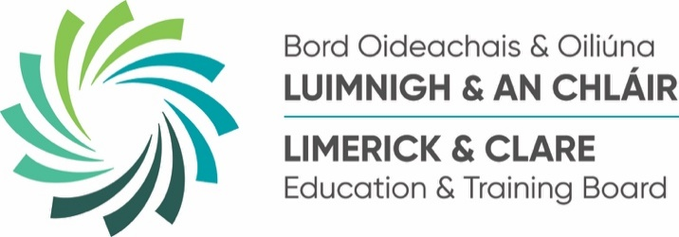
FROM CHALLENGE TO OPPORTUNITY: CLARE STUDENT KEVIN DONAGHY’S JOURNEY THROUGH TERTIARY EDUCATION
Press Release
Tuesday 28th October 2025

Kevin Donaghy was among the many graduates celebrated at Limerick and Clare ETB’s College of FET 2025 conferring ceremonies recently at the Radisson Blu Hotel and Spa in Limerick. His journey showcases how different educational pathways can open doors, especially when the first choice doesn’t work out and is a testament to his determination and the power of Tertiary pathways.

Kevin, who has Asperger’s, Autism, ADHD, and unilateral hearing loss, initially began studying at University of Limerick with an interest in prosthetics, an area connected to his own experience with a cochlear implant. However, he soon realised that course wasn’t the right fit for him and embarked on an alternative pathway. After completing two years with the National Learning Network, Kevin found a more suitable path for him through the innovative Tertiary Degree Programme offered by Limerick and Clare Education and Training Board (ETB) in partnership with Technological University of the Shannon (TUS).
The Tertiary Degree is designed to make higher education more accessible by breaking down traditional barriers such as CAO points. It allows students to start their degree locally at a College of Further Education and Training (FET) campus, saving on fees and gaining valuable support, before transferring to TUS to complete their studies and graduate with a full bachelor’s degree.
Kevin who lives in Shannon, Co, Clare completed his first year of a BSc in Computing, Mobile and Web Development at Limerick and Clare ETB’s College of FET, Mulgrave Street Campus, where he studied subjects like Programming Fundamentals, Web Development, Computer Mathematics, and Foundations of Security. The course’s hands-on, continuous assessment approach suited Kevin’s learning style perfectly, and the support from staff was vital to his success.
His lecturer Brendan O’Sullivan said:
“Kevin’s dedication and positive approach to learning have been key to his progress. He engaged fully with the support services on offer from our AISS and guidance teams at the campus and the practical nature of the course really helped him excel.”
Kevin has now begun the next stage of his journey at TUS’s Moylish Campus, where he will complete the remaining three years of his degree. This pathway not only leads to a QQI Level 8 Bachelor’s degree but also opens doors to careers in dynamic fields like web and mobile app development, software engineering, cloud administration, and more. Graduates can also pursue postgraduate studies at Levels 9 and 10, expanding their expertise even further.
Supported by his proud parents, Kathleen and Eugene Kevin celebrated at Limerick and Clare ETB’s recent College of FET conferring ceremonies with fellow graduates at the Radisson Blu Hotel and Spa in Limerick.
Reflecting on his achievement, he said: "I've invested too much to settle for anything less than a great result"
Kevin’s story highlights how flexible education pathways and personalised support can empower students from diverse backgrounds to succeed and thrive.
For more information about the Tertiary Programme at Limerick and Clare ETB’s College of FET, visit collegeofFET.ie/tertiary.

ENDS

